CRESWELL PARISH COUNCIL
Clerk: Mrs Nikola Evans
www.creswellparishcouncil.co.uk
Email: Clerk@creswellparishcouncil.co.uk

Minutes
Minutes for the Annual Parish Council Meeting held on Monday 9th May 2022 at 7.30pm.
At Stafford North End Community Centre, Holmcroft Road, Stafford ST16 1JG

The Chair welcomed all to the meeting of Creswell Parish Council.

Attendees
Chairman Cllr Thomas Jinks Cllr C Hastings Cllr N Glover Cllr L Howdle Clerk – Nikola Evans

There were two members of the public present.
1 | Election of Chairman  It was proposed and agreed by all that Cllr T Jinks be elected chairman for this year.
2 | Apologies – Cllr M Redfern – Sickness – Accepted. Cllr R Sutherland, Cllr J Pert and Cllr M Winnington were unable to attend due to other commitments.
2 | Declaration of Interest on agenda items - None
3 | Minutes of last Meeting – 04.04.2022 – Approved as a true record of the meeting by all that attended.
Meeting opened to the Public.
4 | To receive a report from Stafford Borough Council - None
5 | To receive a report from Stafford County Council - None
6 | Update from local PCSO - None
7 | Public Participation – Members of the public are invited to address the Council on any issue over which it has power for up to 5 minutes each, with the item lasting a maximum of 20 minutes.  Please see minutes for the annual public meeting which took place before this meeting.
Meeting closed to the public
8 | Planning  - 21/35332/FUL – Plot 1A Redhill Business Pk, Stone Road. – B12/B8 Industrial Units  The parish council discussed this and are concerned about the following.  - Light pollution to the surrounding residential areas.  - Litter  - Traffic
9 | Finance  - Approve of Monthly Payments - approved  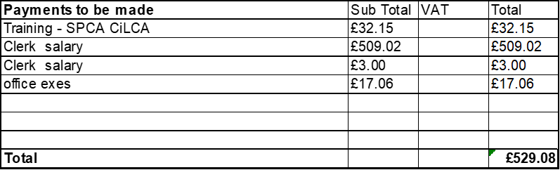  - Approve Budget summary – circulated and approved  - Approve Bank Reconciliation – circulated and approved
10 | To discuss future projects within the community  Suggestion for task and finish groups for the community. The parish council will organise with the support of members of the public. Clerk reported that an individual councillor cannot be delegated to carry out functions of the parish council and it would require a minimum of three councillor’s to be involved. The issues the parish would have, there is nowhere within Creswell that these events could be held. This would be something to consider for the future.  Future projects to consider:  - Bus shelter refurbishment  - Bench cleaning and refurbishment – Cllr Glover and Cllr Jinks will take a look and see if they can refurbish and report at the next meeting. Option to replace, dispose or relocate in the future will be considered.
11 | To approve the following policies  - Standing Orders – circulated and approved  - Financial Regulations – circulated and approved  - Risk Assessment – circulated and approved  - Asset Register – circulated and approved  - Data Protection Policy – circulated and approved  - Complaints Policy – circulated and approved  - Grievance policy– circulated and approved  - FOI Policy – circulated and approved
12 | Councillors Reports  Cllrs are invited to give reports on the parish which do not require a resolution  Councillors reported the following:  - Disused signs are continuing to be collected and put in one place for highways to collect.  - The unofficial public path just off the island being in the wrong place.  - Litter pick to be arranged.
13 | Future meeting dates and next agenda items  Next meeting will be on 6th June 2022 from 7pm at Stafford North End Community Centre  - Perrin Memorial
14 | Meeting Close – The chairman thanked everyone for attending and closed the meeting at 8.35pm

