CRESWELL PARISH COUNCIL
Clerk: Mrs Nikola Evans
www.creswellparishcouncil.co.uk
Email: Clerk@creswellparishcouncil.co.uk

Minutes
Minutes for the Parish Council Meeting held on Monday 4th April 2022 at 7pm.
At Stafford North End Community Centre, Holmcroft Road, Stafford ST16 1JG

The Chair welcomed all to the meeting of Creswell Parish Council.

Attendees
Chairman Cllr Thomas Jinks Cllr Maria Redfern Cllr C Hastings
Cllr N Glover Cllr L Howdle Clerk – Nikola Evans
SCC Cllr J Pert SBC Cllr M Winnington

There was one member of the public present.
1 | Apologies – Cllr N Glover, work commitments - Accepted
2 | Declaration of Interest on agenda items - None
3 | Minutes of last Meeting – 7th March 2022 – Approved as a true record of the meeting by all that attended
Meeting opened to the Public.
4 | To receive a report from Stafford Borough Council – Moved to Item 5  Cllr M Winnington arrived after Cllr Pert and advised a walk-through Marston Grange development had taken place and reported the following issues from residents.  - Road works  - Flooding  - HS2
5 | To receive a report from Stafford County Council – Moved to item 4.  Cllr J Pert reported on the following:  - Marston Grange – Foul sewer movement. Works are due to finish on 23.04.22 we are aware its causing delays however the utility services must be granted access to carry out the necessary works.  - Whitgreave Lane, A34 road works. The closure was originally for 14 months however this has now been reduced to 7 months.  - Pets @ home, development is coming along and is expected to create over 750 jobs for local people.  Covid 19, Although the level of people catching the virus is high the vaccine is providing a good level of protection and hospital and intensive care admissions remains low compared to previous year.
6 | Update from local PCSO - None
7 | Public Participation – Members of the public are invited to address the Council on any issue over which it has power for up to 5 minutes each, with the item lasting a maximum of 20 minutes.  A resident asked for an update on the development at Creswell Grove, Strawson’s. Clerk will continue to try and arrange a meeting.
Meeting closed to the public
8 | Planning  - 22/3554/FUL - Pets at Home, Redhill, Stafford - Additional information has been submitted with regard to the above application, covering letter, travel plan, and supporting arboriculturally information available to view at www.staffordbc.gov.uk/planning-public-access  No comments were made by the parish council.
9 | Finance  - Approval of Payments - Approved  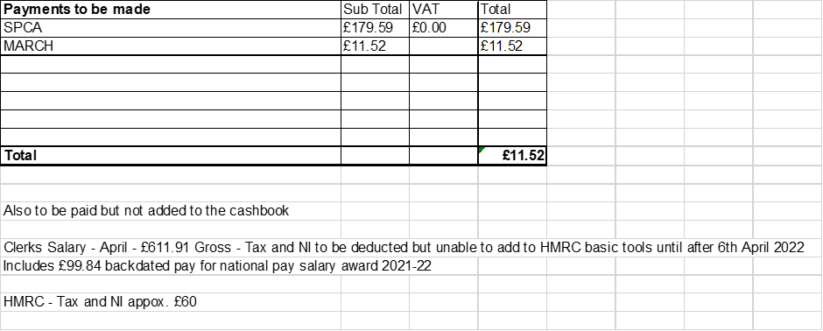  - Approve Budget summary – circulated before the meeting and approved  - Approve Bank Reconciliation – circulated before the meeting and approved  - End of year Bank reconciliation for 2021/22 – circulated before the meeting and approved
10 | To discuss plans for Perrin Memorial Day  Approved to hold refreshments after the service. Clerk to send out invitations and start organising.
11 | To discuss smaller councils committee letter – circulated to all council members before the meeting, no comments received at this meeting, Cllr’s will email clerk to respond before the deadline.
12 | Councillors Reports  Cllrs are invited to give reports on the parish which do not require a resolution  Cllr M Redfern reported on the following:  - Concern from residents over the potholes – Cllr J Pert advised residents to report them via the online reporting system.  - Residents on Creswell Grove were disappointed there was to be no amenity visits this year. Clerk explained that an email had been sent to residents giving instructions on how they can ask for help to remove large items that cannot be put in their normal waste. The parish council decided against the visit because it did not benefit the whole parish.  Cllr T Jinks reported on the following:  - Concern over the state of the roads at Marston Grange. _ Cllr Pert and Cllr Winnington advised that as this estate has not yet been adopted by SCC then liability lies with the developers.
13 | Future meeting dates and next agenda items  Next meetings to take place will be on 9th May 2022 @ Stafford North End Community Centre – Annual Public Meeting from 7pm and Annual Parish Council Meeting to follow from 7.30pm
14 | Meeting Close – The meeting was closed at 20.01pm

