CRESWELL PARISH COUNCIL
Clerk: Mrs Nikola Evans
www.creswellparishcouncil.co.uk
Email: Clerk@creswellparishcouncil.co.uk

Minutes
Minutes for the Parish Council Meeting held on Monday 10th January 2022 at 7pm.
At Stafford North End Community Centre, Holmcroft Road, Stafford ST16 1JG

The Chair welcomed all to the meeting of Creswell Parish Council.

Attendees
Chairman Cllr Thomas Jinks Cllr Maria Redfern Cllr C Hastings
Cllr N Glover Cllr L Howdle Cllr R Sutherland SBC Clerk – Nikola Evans

There were two members of the public present.

1 | Apologies – Cllr Pert and Cllr Winnington
2 | Declaration of Interest on agenda items - None
3 | Minutes of last Meeting – 1st November 2021 – approved as a true record of events by all that attended
Meeting opened to the Public.
4 | To receive a report from Stafford Borough Council  Cllr R Sutherland reported on the following:  - Pets at home site – A meeting will take place in due course and Cllr Sutherland will provide an update  - M6 Smart motorway, Cllr Sutherland will provide an update at the next meeting  - Possible planning application for the MOD site. The Parish council may wish to comment on. Clerk and Cllr Sutherland will advise when received.
5 | To receive a report from Stafford County Council  Cllr Pert was unable to attend and a report was read out by the Clerk  - Works starting on the A34 to install the new Pets at Home roundabout, which will last until the end of 2022.  - Works also starting on the top end of Beaconside to make the road a dual carriageway all the way along to the MOD are now planned to start in March / April 2022.  - There are also some speed limit changes planned for the area around the Beaconside / A34 roundabout, principally bringing the 40mph speed limits down to 30mph to help improve safety and traffic flows. I guess the practical reality is that most people will already be doing 30mph through these areas in any case most of the time.  - Vaccinations and boosters – residents urged to get vaccinated and have their booster if they are eligible.
6 | Update from local PCSO - None
7 | Public Participation – Members of the public are invited to address the Council on any issue over which it has power for up to 5 minutes each, with the item lasting a maximum of 20 minutes.  A member of the public wished to advise that the A34 crash barrier has finally been repaired.
Meeting closed to the public
8 | Planning - None
9 | Finance  - Approval of Payments - Approved  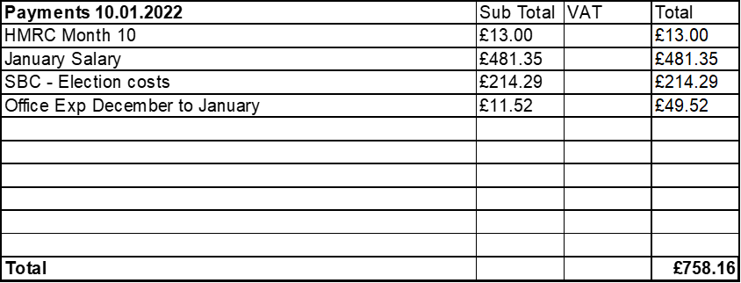  - Approve Budget to performance summary - Approved  - Approve Bank Reconciliation - Approved  - Approve clerks CiLCA training fee and registration £685 – divided between all three of the clerk’s councils - £228.34 each. - Approved
10 | Traffic and Highways
11 | Footpaths, Village Maintenance  - Bench repairs/maintenance – Cllr Redfern has access to replacement wood and will supply to Cllr Jinks and Cllr Glover to carry out repairs on the bench outside the Shire Pub.
12 | Events within the Parish  - Queens Jubilee – No plans to take part, residents normally organise their own events.
13 | Correspondence  - Newsletter – Ongoing discussions about the reintroduction of a newsletter.
14 | Councillors Reports  Cllrs are invited to give reports on the parish which do not require a resolution  Cllr Glover reported on the following:  - Sign still obstructing view for on coming traffic on downward slip road towards junction 14 of the M6  - Multiple areas there are still street signs / maintenance signs left lying around  Cllr Jinks reported on the following:  - Noticeboard for Marston Grange – Further discussions taking place.  Cllr Redfern reported on the following:  - Water under the motorway got into gas pipes causing disruption and has since been resolved  - Daffodils have been replanted at junction 14 roundabout.
15 | Future meeting dates and next agenda items  Next meeting will take place on 7th February 2022 @ Stafford North End Community Centre
16 | Meeting Close - meeting closed at 20.06pm

