CRESWELL PARISH COUNCIL
Clerk: Mrs Nikola Evans
www.creswellparishcouncil.co.uk
Email: Clerk@creswellparishcouncil.co.uk

Minutes
Minutes for the Parish Council Meeting held on Monday 1st October 2021 at 7pm.
At Main School Hall, Tillington Manor Primary School, Young Avenue, Holmcroft

The Chair welcomed all to the meeting of Creswell Parish Council.

Attendees
Chairman Cllr Thomas Jinks Cllr Maria Redfern Cllr C Hastings
Cllr N Glover Cllr L Howdle Cllr M Winnington SBC
Cllr J Pert SCC Clerk – Nikola Evans

1 | Apologies – Cllr R Sutherland
2 | Declaration of Interest on agenda items - None
3 | Minutes of last Meeting – 4th October 2021 – Approved as a true record
Meeting opened to the Public.
4 | To receive a report from Stafford Borough Council  Cllr M Winnington reported on the following:  - Delay in planning application process  - Entrance way to new Service station, Strawsons. Very untidy – clerk will write to Strawsons.  Cllr Glover asked if we could have some help with the HGV drivers on and around Mustang Drive, defecating in the bushes. Clerk to report to Cllr Winnington and Cllr Sutherland to pass onto the Environmental Health.
5 | To receive a report from Stafford County Council  Cllr J Pert reported on the following:  - Pets at home development, construction is going well. There will be some disruption to highways, A34 roundabout and roads that link, due to start mid-December and carry on for around 12 months.  - Delayed works by Taylor Wimpey for the new dual carriageway, due to start March 2022.  - Reduction in speed limits in surrounding area of A34  - Infection rates in Stafford Borough area have now come down, the need to get vaccinated and carry out lateral flow testing remains important. Hospitalisation is going up slightly but not significantly.  - Speed issues, Cllr Pert suggested providing feedback on the key priorities in the proposed Police and Crime Plan, and Fire & Rescue Plan 2021-2024.
6 | Update from local PCSO - None
7 | Public Participation – Members of the public are invited to address the Council on any issue over which it has power for up to 5 minutes each, with the item lasting a maximum of 20 minutes.  A resident commented that there was nothing in the budget for capital projects:  - Benches particularly outside The Shire Horse, need some attention – Clerk will contact contractors to repair.  - Martson Grange noticeboard
Meeting closed to the public
8 | Planning - None
9 | Finance  - Approval of Payments – Approved  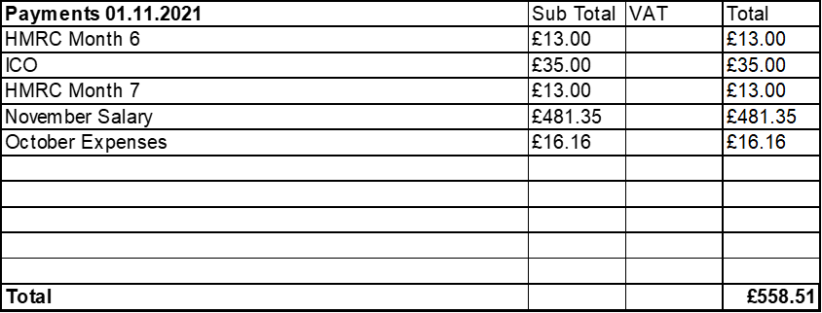  - Approve Budget to performance summary - Approved  - Approve Bank Reconciliation - Approved  - Approve 2022/23 Budget and precept request – Approved budget and to increase precept by 2.5% for 2022/23
10 | Traffic and Highways  - Speedwatch group, up and running residents of Creswell Grove have been asked to contact the lead coordinator.  - Flood on M6 junction 14 Northbound Motorway slip road off Island. Clerk to chase.
11 | Footpaths, Village Maintenance  - Footpath at the bottom of Strawsons site – Clerk advised that it isn’t a right of way, and it is a permissible footpath, clerk will write a letter to Strawsons asking if it will be reopened.  - Cycle path by Iron Mountain, has been reported and advised will be cut back. Cllr Glover will supply photos.
12 | Events within the Parish  Cllr L Howdle raised a Suggestion for the queens Jubilee – Patch of land at the bottom of Strawsons development site – planting trees for a community wood.
13 | Councillors Reports  Cllrs are invited to give reports on the parish which do not require a resolution  Cllr Redfern reported on the following:  - Speed signs designed by children along the road
14 | Future meeting dates and next agenda items  Next meeting will take place on 6th December 2021 @ Tillington Manor Primary School from 7pm  - Newsletter  - Queens Jubilee – Tree planting  - Bench repair
15 | Meeting Close – The Chairman thank everyone for attending and closed the meeting at 20.30pm

