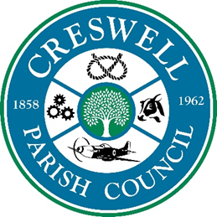
Clerk: Mrs Nikola Evans
Address: 45 Thorn Close, Brereton, Rugeley, Staffs. WS15 1TA www.creswellparishcouncil.co.uk
Tel: 07971226170 Email: Clerk@creswellparishcouncil.co.uk

Newsletter – February 2024
Your councillors – Cllr M Redfern - Vacant seats - 4
Who needs a Parish Council?
Anyone who is interested in local democracy and who does not wish to lose the money that is available to Local Councils, either under direct tax raising powers or access to local development funding under the Community Infrastructure Levy.
Local Councils have many statutory powers to provide improvements in the area and support genuine community groups with grant funding from their precept.
Local Councils are corporate bodies, that is to say, the decisions are taken by the Council as a whole (either unanimously or by a majority decision) not individual Councillors. The parish council is responsible to the community, they represent you.
If the Parish Council is disbanded, the area will lose out financially and access to, and co-operation with, the higher tiers of local authority.
Parish Councils have the right to comment on planning applications within their parish. They are not statutory consultees but their views must be considered by the district Council, alongside statutory consultees and district Council Planning Officers.
If you care about your local community, you would only need to commit a few hours to (parish councils have a statutory duty to hold a minimum of four meetings a year, which must include the Annual Parish Council Meeting and can be quarterly, bi-monthly or monthly, it’s the parish council’s choice) prepare for, attend meetings and raise residents’ concerns.
Parish Councils should be a-political, so you do not have to be affiliated to a political party and you do not need any special qualifications, just a concern about future of Creswell.
Contact the Clerk for details of how to apply.
Village maintenance – All contracts ended on 31st December 2023, your parish council is inquorate and therefore unable to make any new decisions on future contracts.
Creswell Grove Development – Strawson’s Property have advised they are hoping to start late spring early summer.
If you would like further information or report any issues, please do not hesitate to contact the clerk, I am more than happy to help.

